Linear Search or Sequential Search
Linear search is a method for finding a particular value in a list, which consists of checking every one of its elements, one at a time and in sequence, until the desired one is found.
Linear search is the simplest search algorithm. For a list with n items, the best case is when the value is equal to the first element of the list, in which case only one comparison is needed. The worst case is when the value is not in the list (or occurs only once at the end of the list), in which case n comparisons are needed.
Worst Case : In Big O Notation it is O(N).
Best Case : In Big O Notation it is O(1).
Binary Search
Array needs to be sorted first. Same technique as divide and conquer. Array is broken by 2 till the element is found.
Can be implemented recursively or iteratively (for loop)
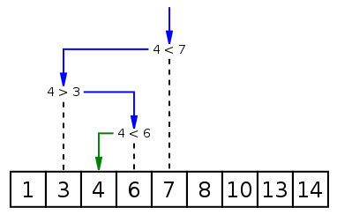
Worst case performance | O(log n)
Best case performance | O(1)

